Practical 2

Step 1 : Open Google Cloud Console & Click the hamburger menu

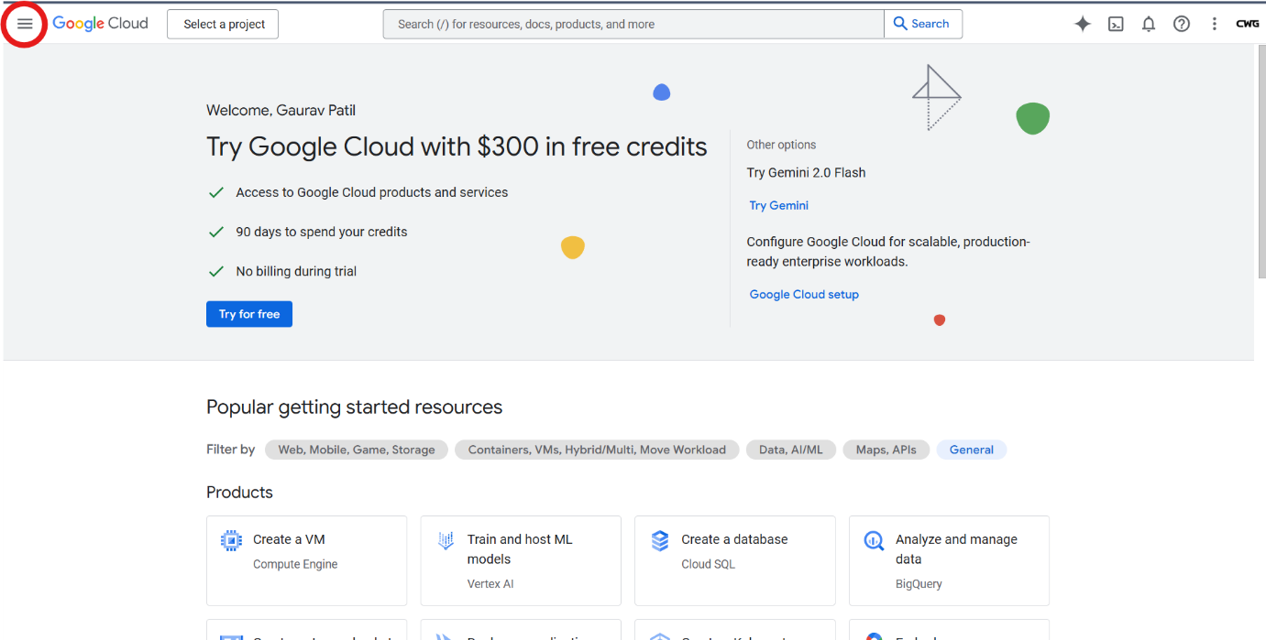

Step 2 : Click the Cloud Overview option & then click Dashboard

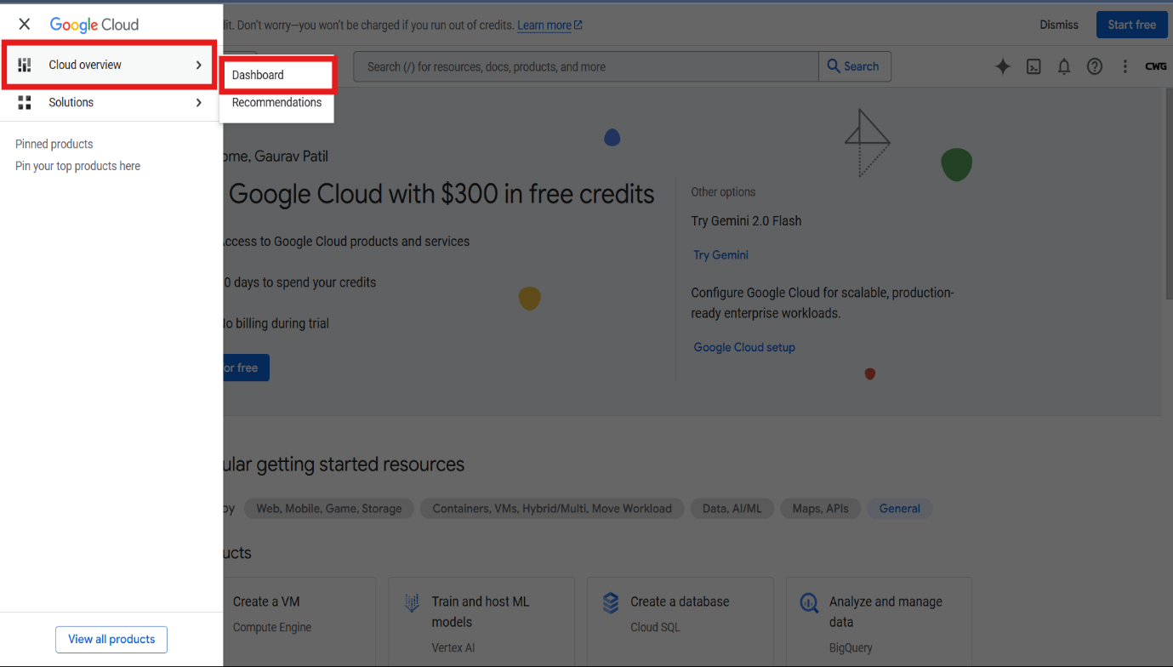

Step 3 : Click Create Project

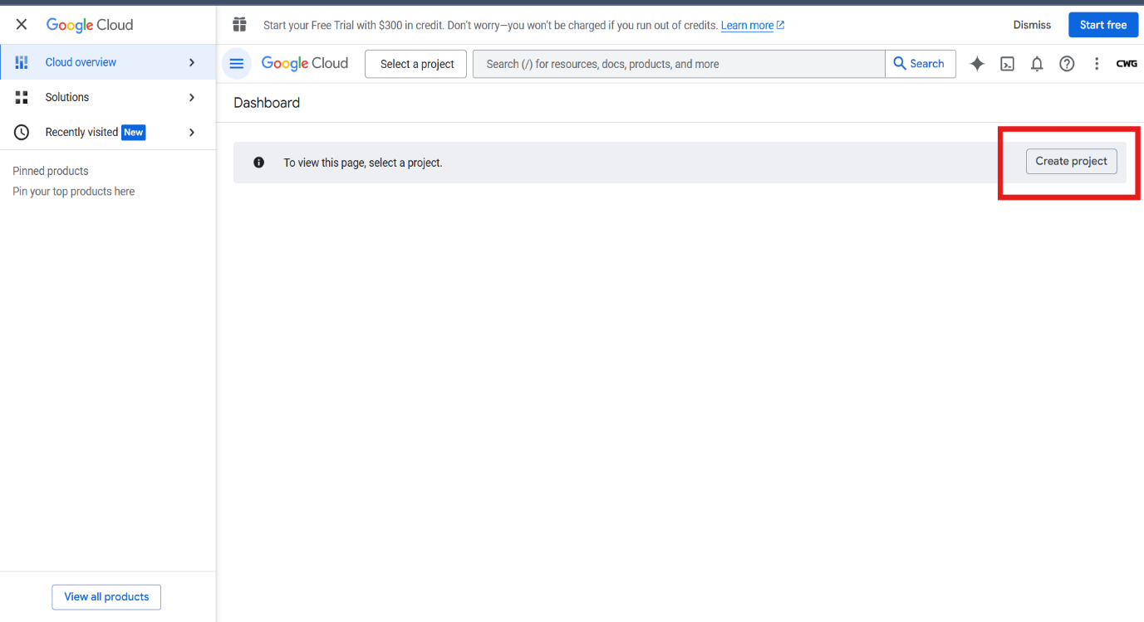

Step 4 : Write Project name in Input box & press the Create button

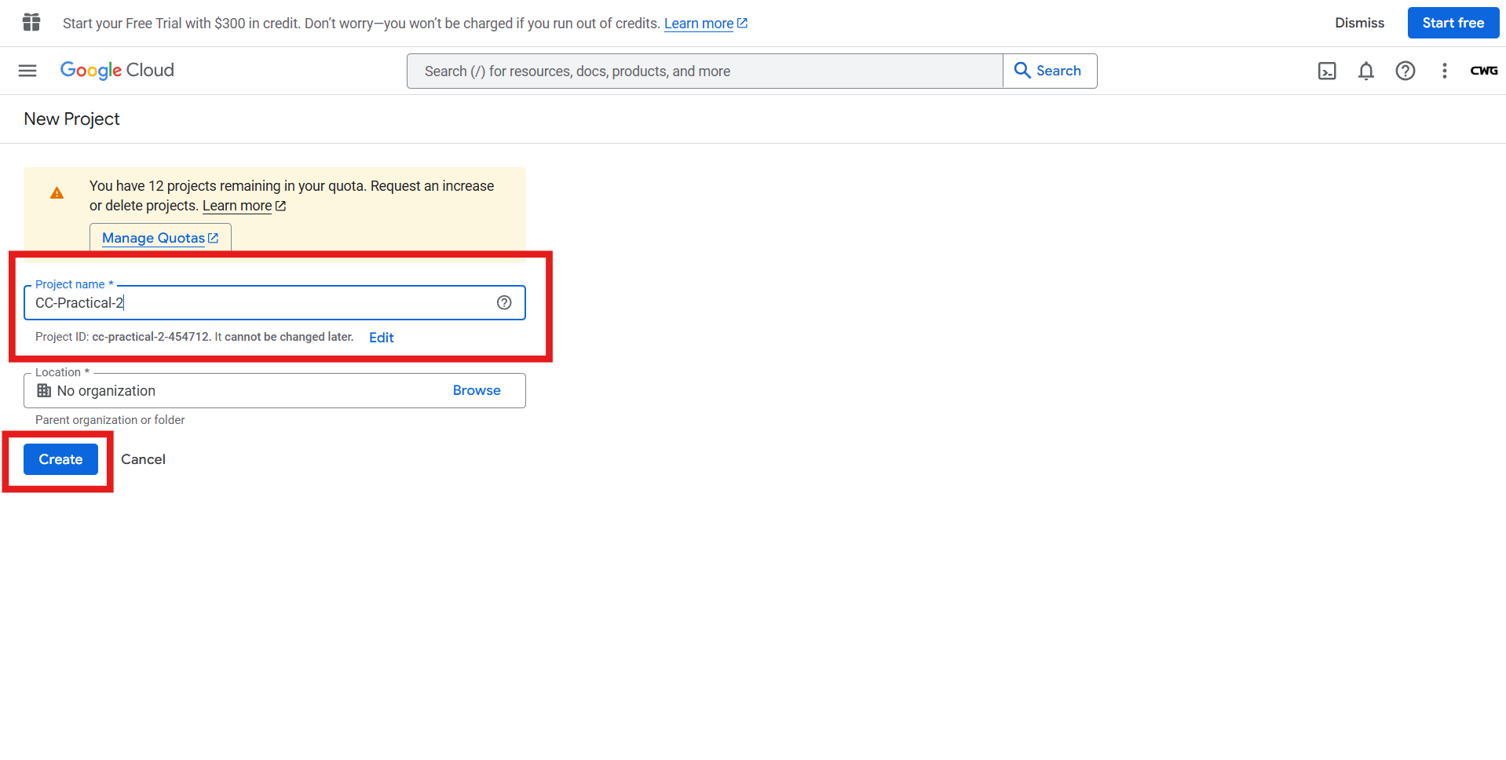

Step 5 : Search for admin api in the search bar & then click on App Engine admin Api

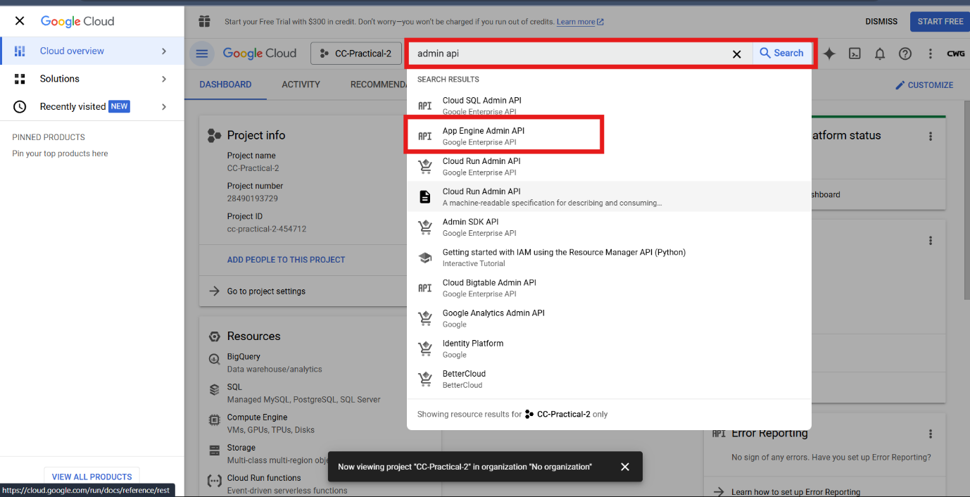

Step 6 : Click on ENABLE Button

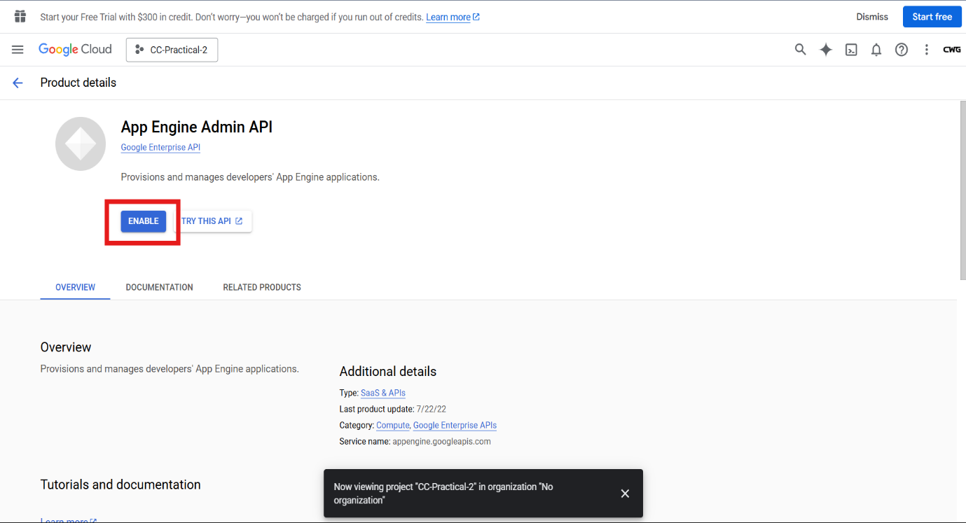

Step 7 : Open new Tab & login to Github and create a Repository . After creating a repository create a python file in same repository to simply print “Hello World”

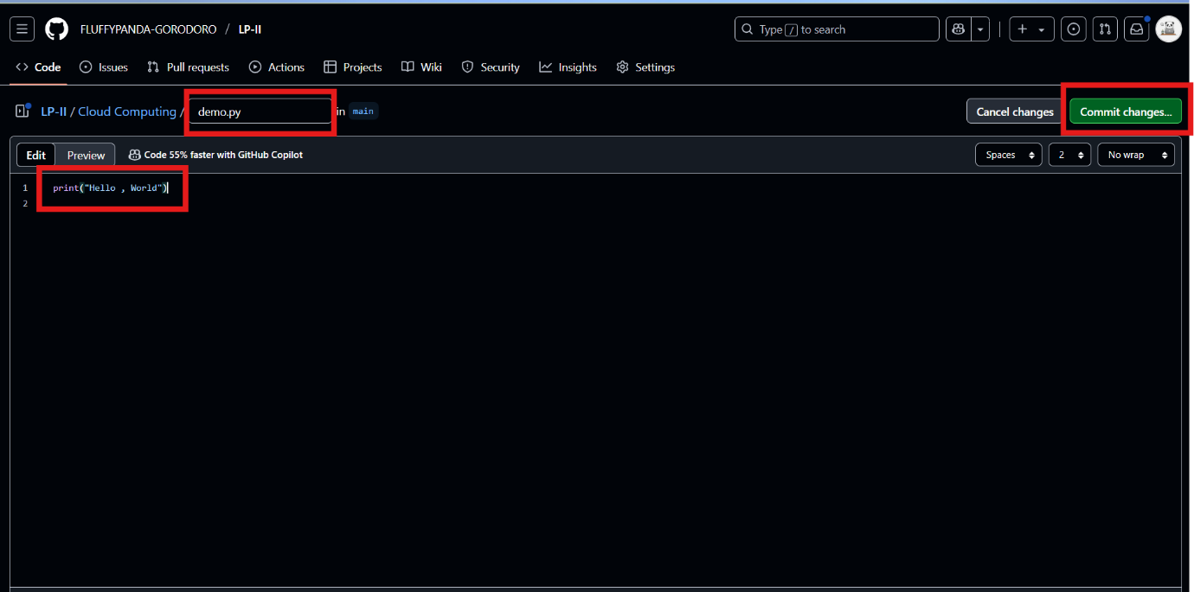

Step 8 : After creating python file . Click on the Code Button

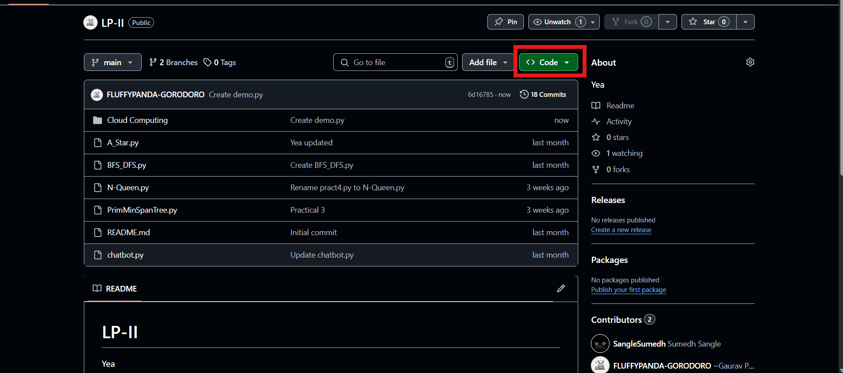

Step 9 : Copy the HTTPs path of the repository

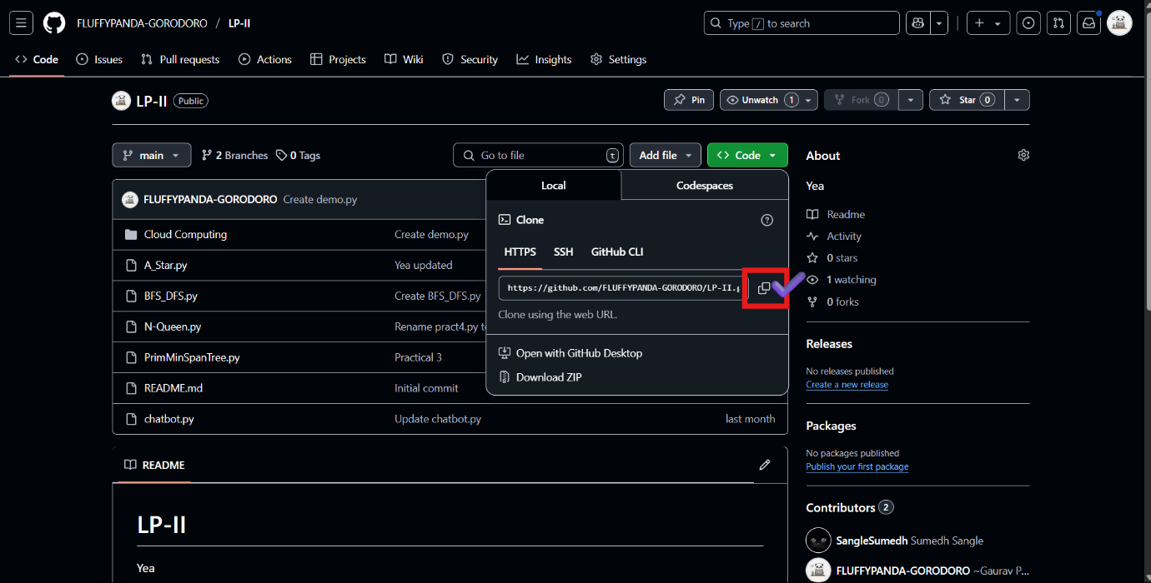

Step 10 : Come back to Google Cloud Console & Click on terminal

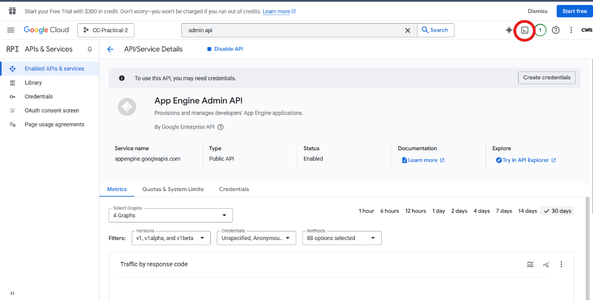

Step 11 : Write git clone command in the terminal

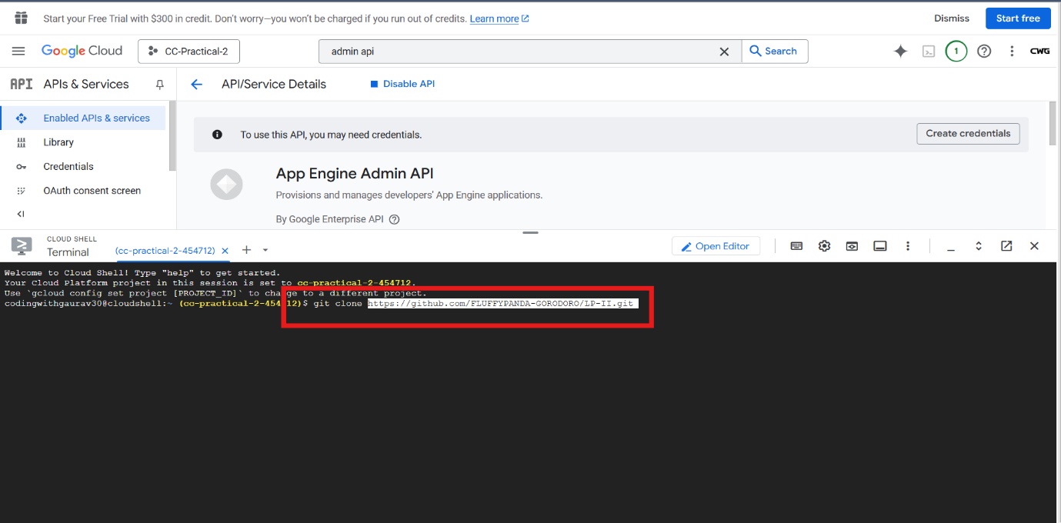

Step 12 : Change the directory of the clone using cd command & then run the python file .

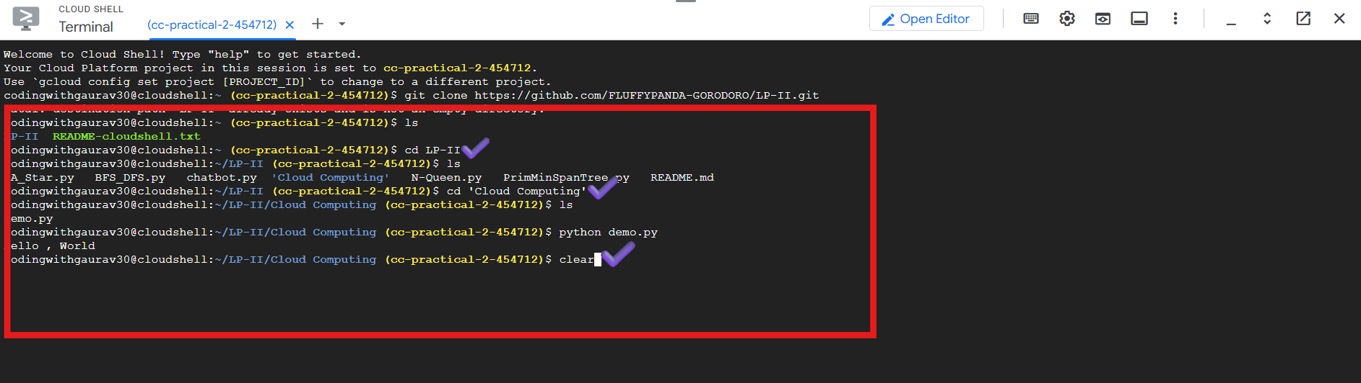

Step 13 : Write command to start the server & Click on the Web Preview Button

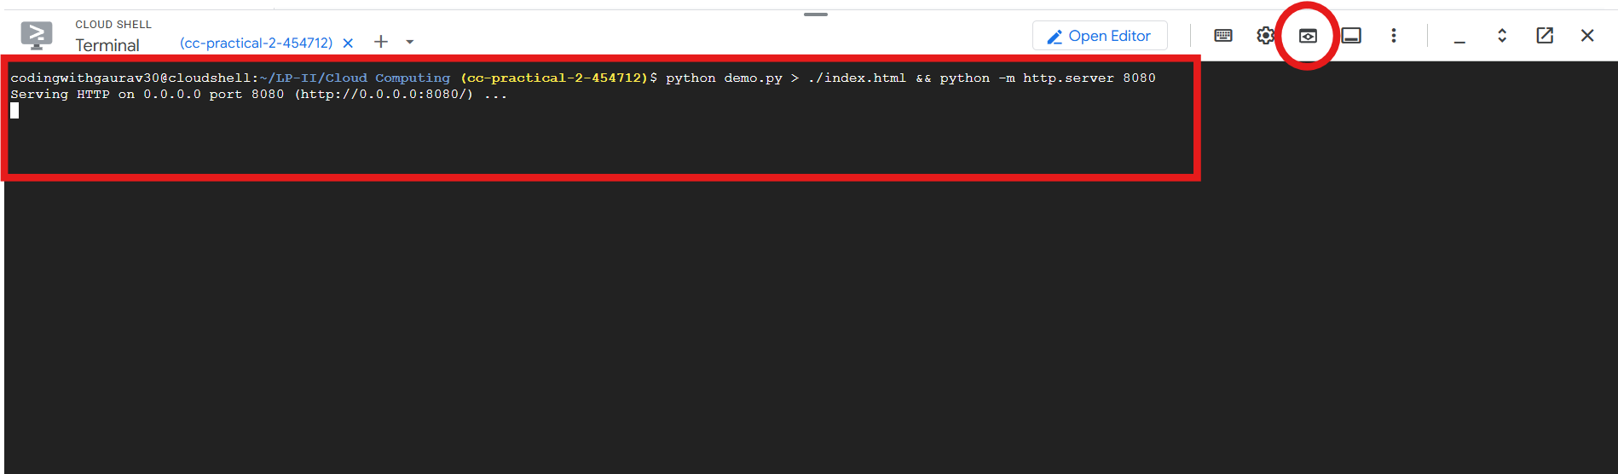

Step 14 : Click on “Preview on port 8080”

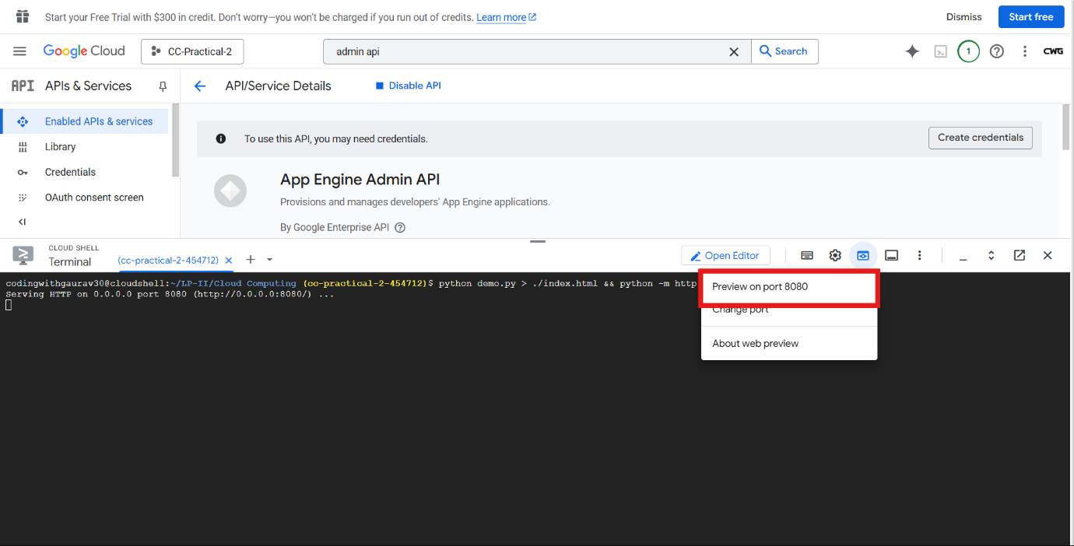

Step 15 : Good Job , You Have completed the Cloud Computing Practical 2 . Happy Coding !

Output

